

School: ............................................................................................................. Campus: ....................................................... Academic Year: ...................... Subject Name: ........................................................... Subject Code: ..........................

Semester: ............... Program: ........................................ Branch: ......................... Specialization: .......................... Date: .....................................

(Learning by Doing and Discovery)

**\* Coding Phase: Pseudo Code / Flow Chart / Algorithm**

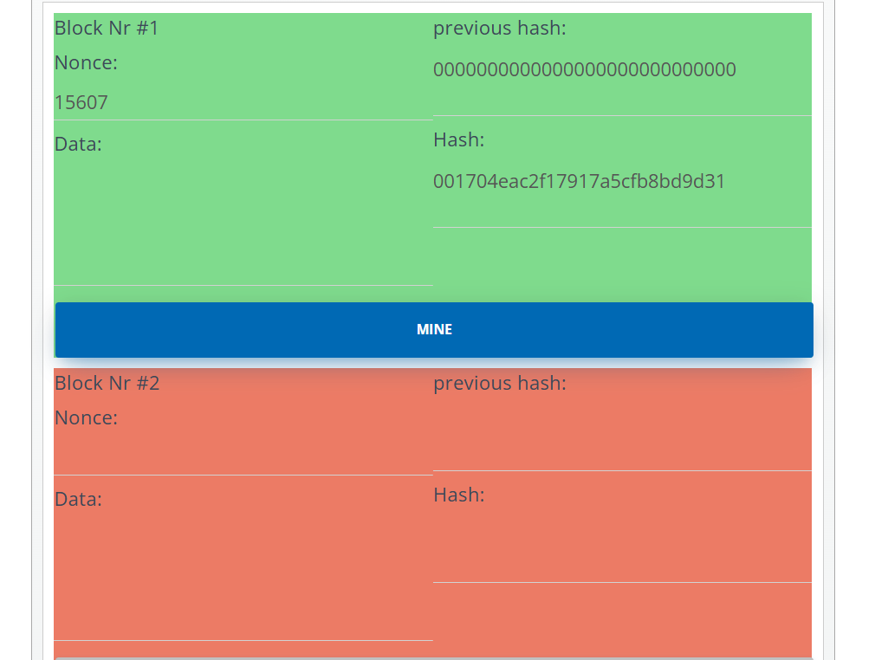

# * Softwares used

* **Testing Phase: Compilation of Code (error detection)**
* **Implementation Phase: Final Output (no error)**

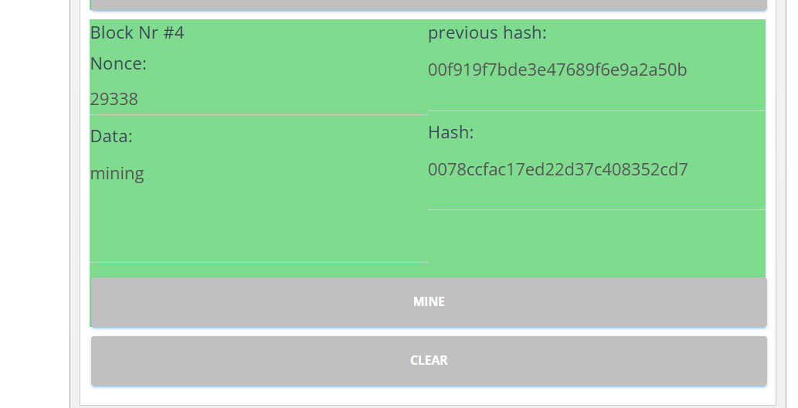

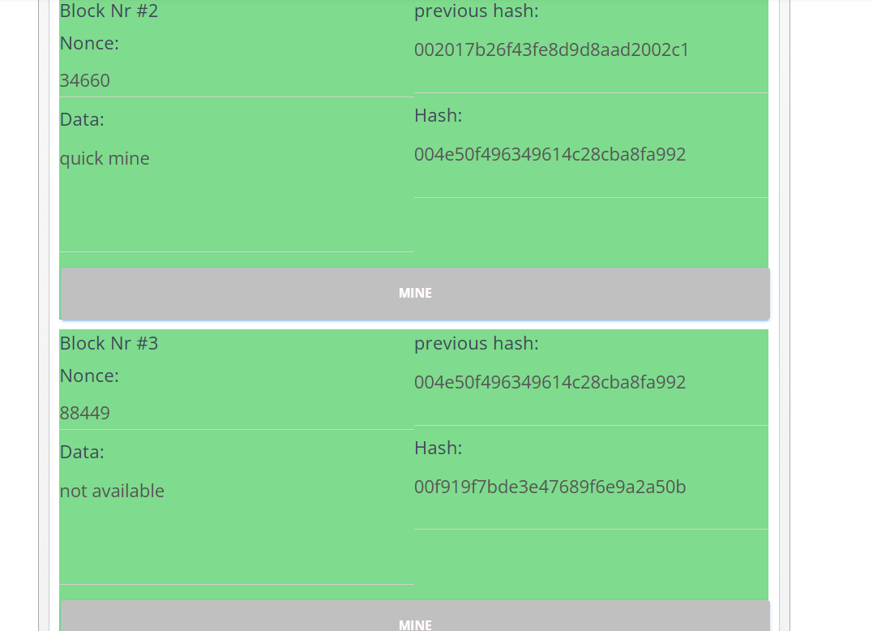

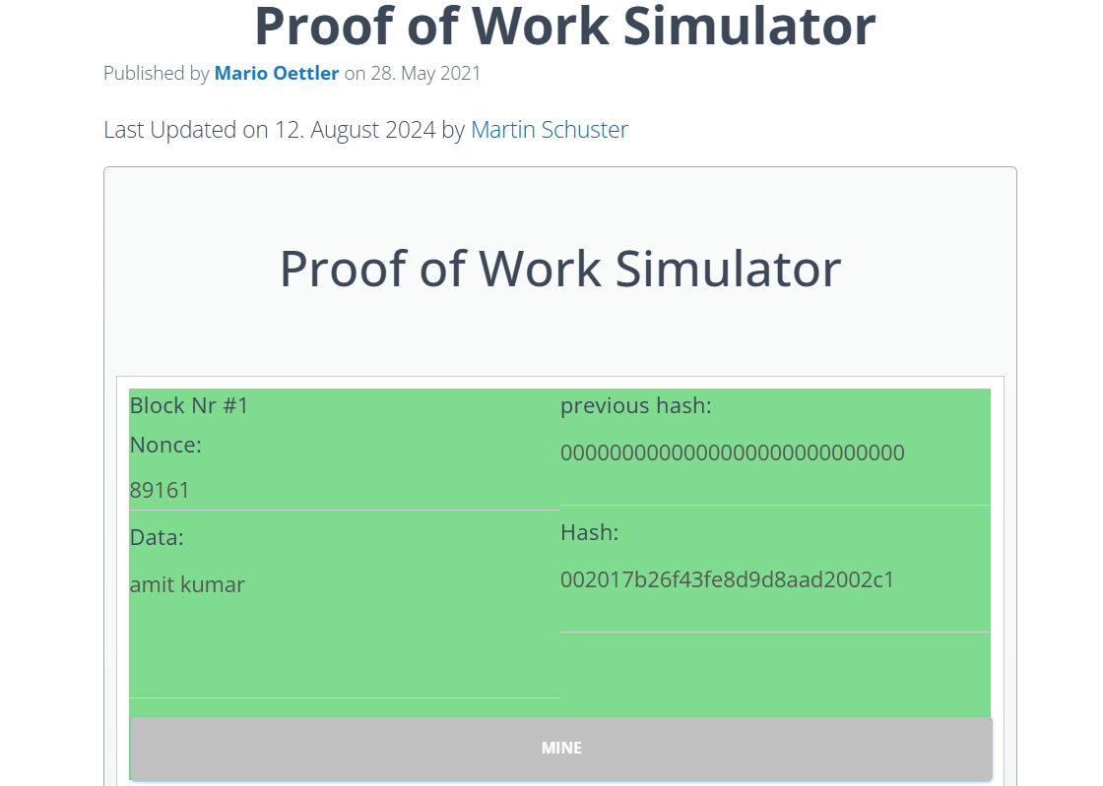

* **Implementation Phase: Final Output (no error)**

Applied and Action Learning

# * Observations

* users can experience the mining process firsthand.
* The simulation allows you to click "mine" to attempt to solve a cryptographic puzzle, which involves finding a nonce that produces a hash with a specific number of leading zeros.
* Once the puzzle is solved, the block turns green, indicating a successful proof of work.



|  |  |  |  |
| --- | --- | --- | --- |
| **Rubrics** |  |  |  |
| Concept | 10 |  |  |
| Planning and Execution/  Practical Simulation/ Programming | 10 |  |  |
| Result and Interpretation | 10 |  |  |
| Record of Applied and Action Learning | 10 |  |  |
| Viva | 10 |  |  |
| **Total** | **50** |  |  |

***Signature of the Student:***



***Signature of the Faculty:***